Carter Gospel Fellowship

Tyler Greathouse – Senior Pastor
Church Phone – 605-879-2536
Cell Phone: 605-841-0250
Website: cgfellowship.com
Email: pastorgreathouse@gmail.com

“To develop a heart for God’s word, glorifying Him,
By teaching the love and grace of Christ.”

Welcome

Tithe and Worship

- #105 He is Lord

- What a Day That Will Be!

- #354 Leaning on the Everlasting Arm

Prayer and Praise

Message: –Kingly Reactions - John 12:12-19

Closing Song: #516 He’s Everything to Me

Benediction

Weekly Services
Sunday School – Sundays @ 10:00 A.M.
Worship Service – Sundays @ 11:00 A.M
Youth Group – Wednesdays @ 7:30 PM
Midweek Prayer Meeting and Bible Study– Wednesdays @ 7:30 P.M
Men’s Breakfast – Saturdays @ 7:30 A.M. at Jeff’s Gun Vault
Announcements.

- This year, to help with any kids/youths seeking to go to a Christian camp, there will be a camp ministry scholarship fund. If you want to help fund this scholarship, place cash or a check in the offering box at the mission table. If writing a check, write to “Carter Youth Fellowship.” See Pastor Tyler to sign up for any child/youth wanting part of this fund.

- As Easter rapidly approaches, there are a few things to note. First, Our Good Friday Service will be on March 29th at 7:00 PM. Also, Pastor Tyler will send daily devotionals via email from this Monday until Resurrection Sunday to help prepare and remind us of such an important event. If you are not on the email list and would like to receive these devotionals, see Pastor Tyler.

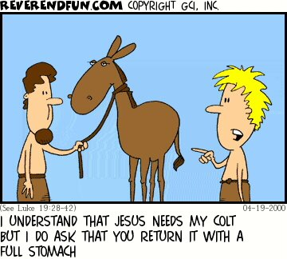

Upcoming Events:

Good Friday Service
Friday, March 29th at 7:00 PM

Prayer Requests.

- Continue to pray for health concerns for Dale Waters and Dick and Mary Buchanan.

- Missionaries of the Week: The Piatts, RHMA, and the Mannas.

- Continue to pray for Les Clevenger as he continues to recover. The reports continue to show improvements.

- Pray for Brian Balster as he is back in the States. Pray for the impacts of the recent workshops.

-Continue to pray for Pastor Justin Wheadon as he recovers from his heart attack.

- Continue to pray for Meagan as she continues through cancer treatments.

- Continue to pray for Leah B. as she continues her journey with seizures. They have recently changed medication, and she is doing significantly better. Pray for this medication to continue to work.

- Pray for our community as we shine the light of Christ!

- Pray for the camp ministry, such as VCBC, as they prepare for the summer.

“So they took branches of palm trees and went out to meet him, crying out, “Hosanna! Blessed is he who comes in the name of the Lord, even the King of Israel!”
John 12:13
Hosanna in the Highest!

Carter Gospel Fellowship
March 24th, 2024

